**PIZZA SALES SQL QUERIES**

**Total Revenue:**

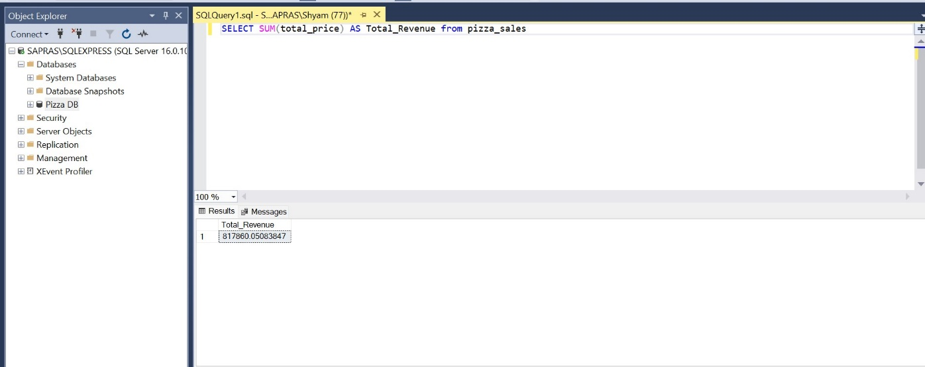

**Average Order Value**

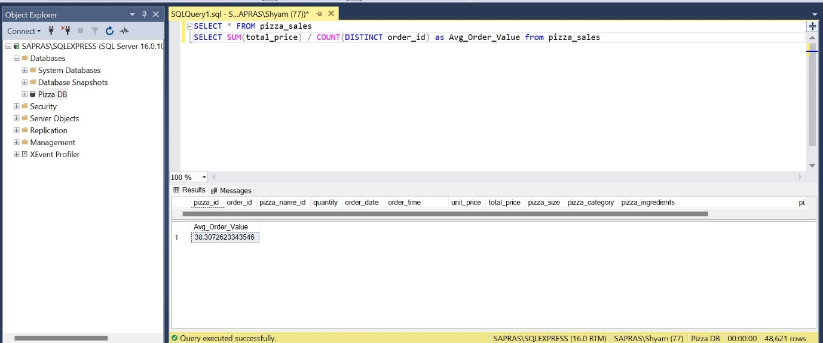

**Total Pizzas Sold**

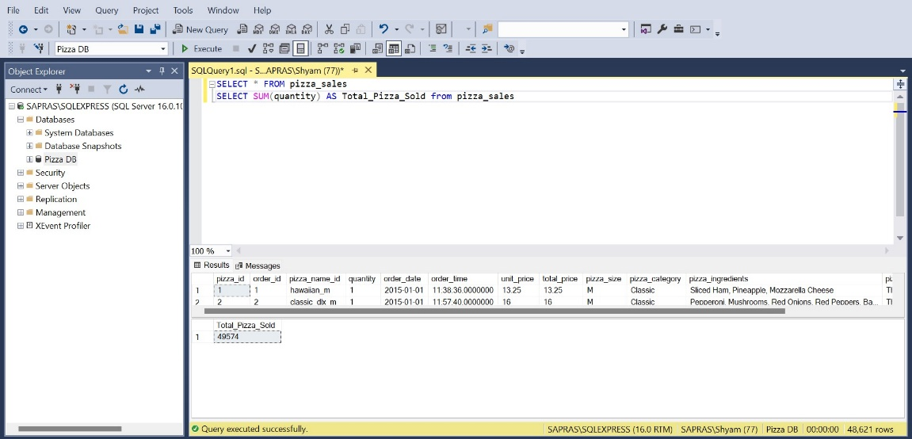

**Total Orders**

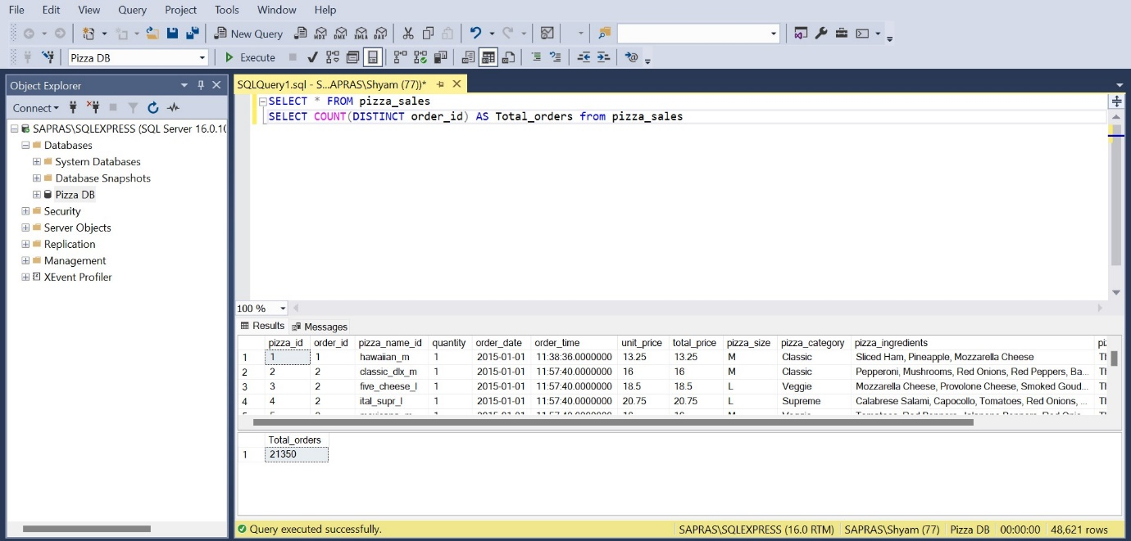

**Average Pizzas Per Order**

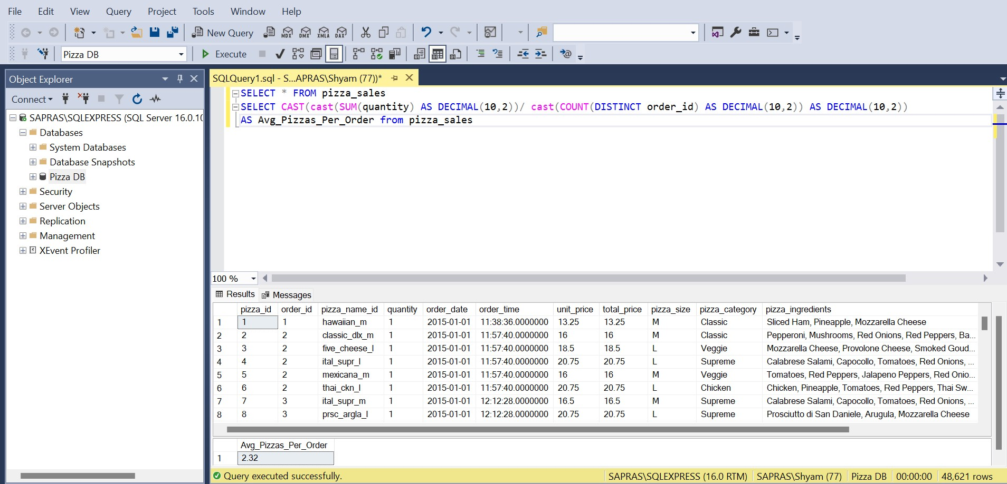

**Daily Trend for Total Orders**

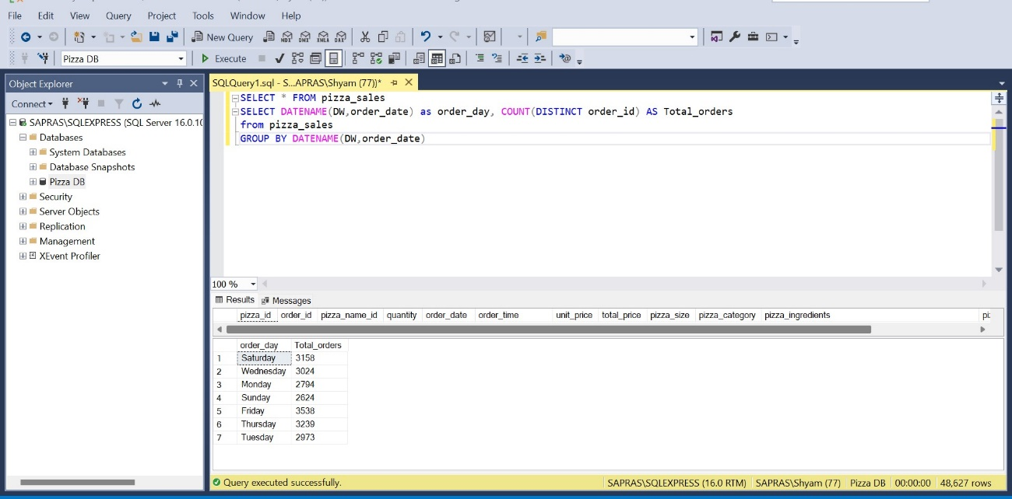

**Monthly Trend for Orders**

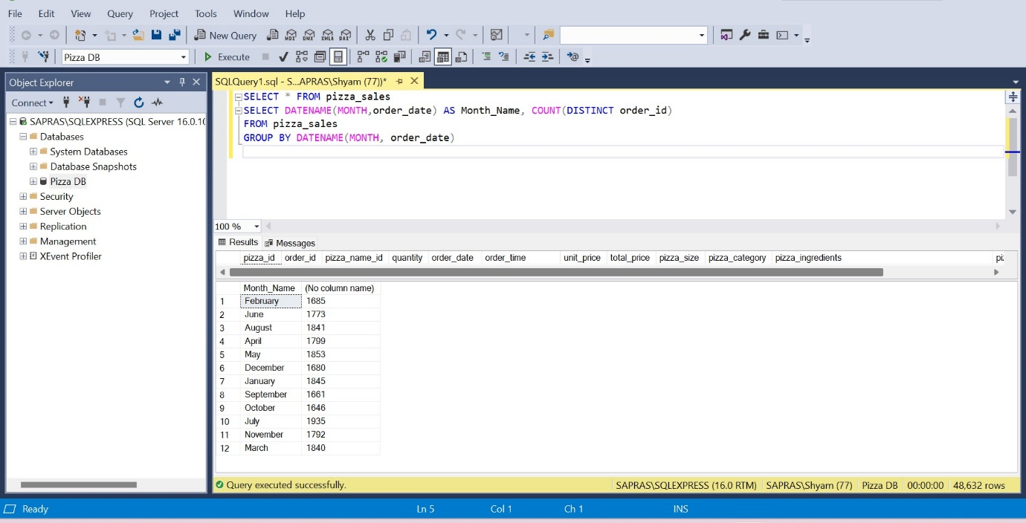

**% of Sales by Pizza Category**

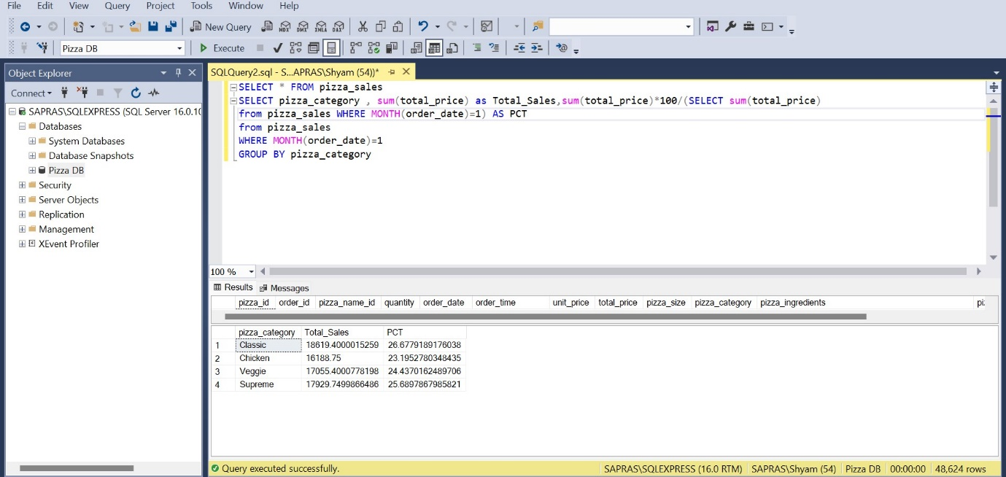

**% of Sales by Pizza Size**

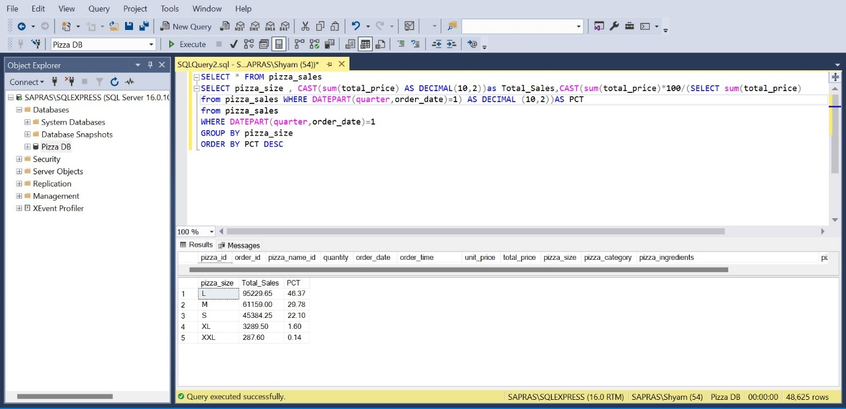

**Top 5 Pizzas by Revenue**

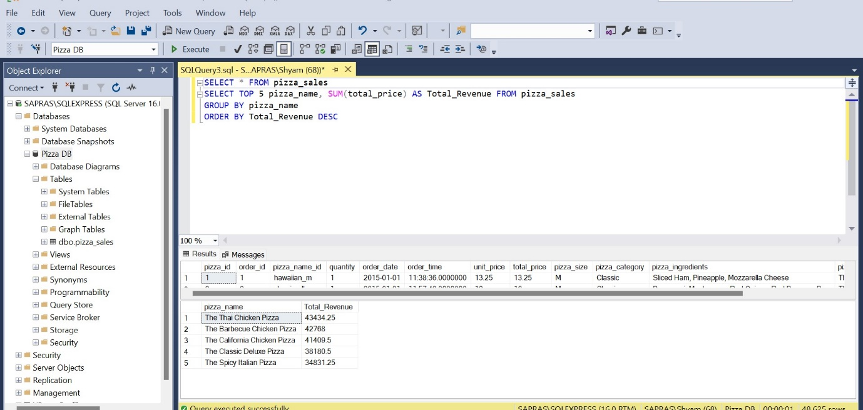

**Bottom 5 Pizzas by Quantity**

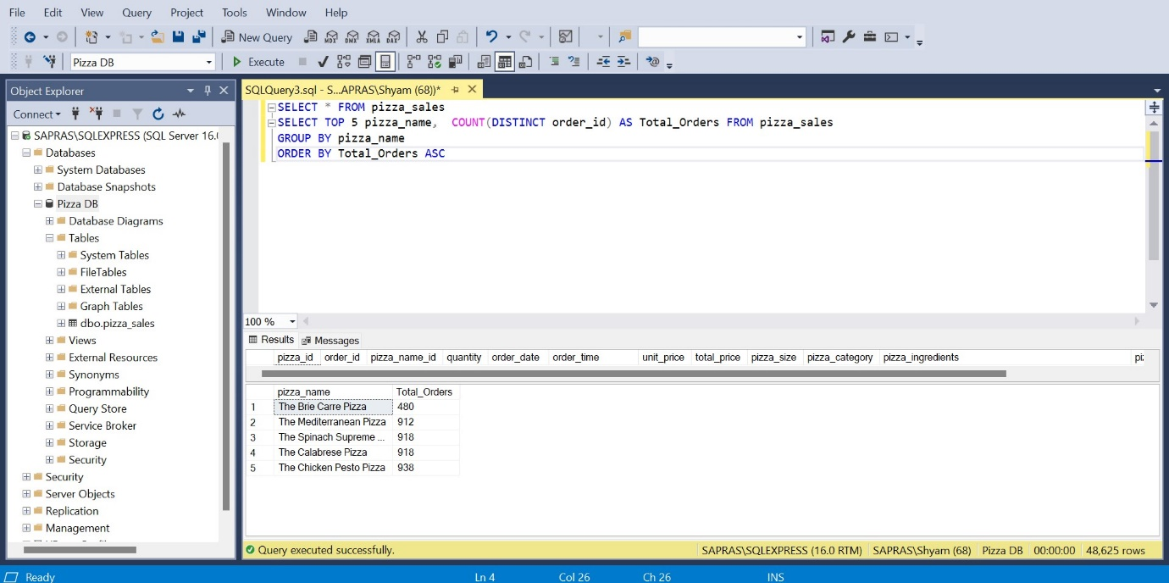

**Top 5 Pizzas by Total Orders**

